**Map Method**

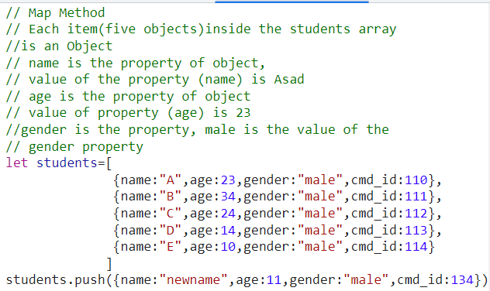



students.map()



**Passing Function to map method:**

students.map(cmd_id_function)

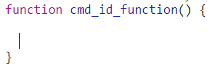

**Map Method calling function (cmd_id_function)**

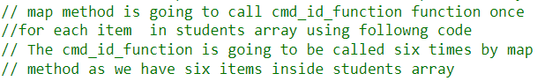





**Value Returned by Map Method**

Each time map method calls the function mentioned inside () of the map method, the returning value of the function get added to the new array that is returned by the map method.

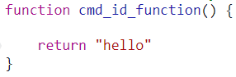

**Value returned by the map method(map is a method called by students array) is a new array:**

 returns an array

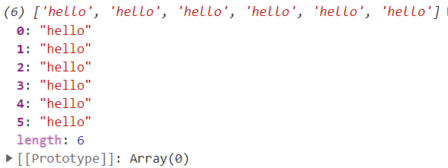

We have called cmd_id_function **six** times,as we have six items in the students array.

**Passing current Item of the array to the function on current call to the function:**

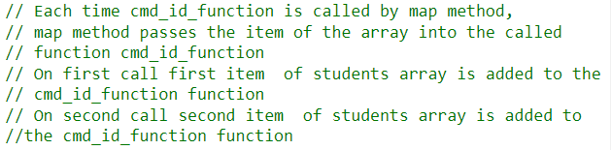



**Accessing the items of the array inside the function:**

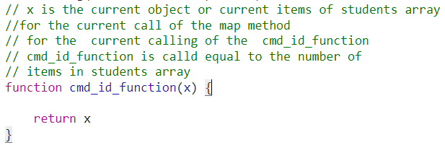



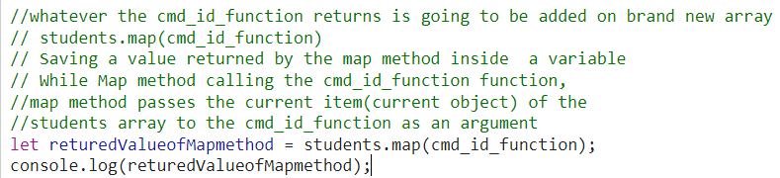

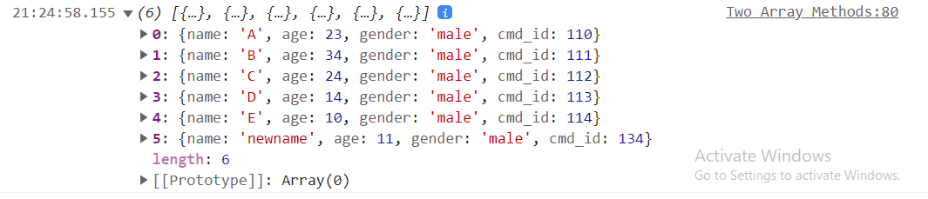

**Tapping into the current object’s property inside array:**

Name properties’ values gets added to the new array that is returned by the map method.

